# HTTPS配置指导

1、需要在IIS对站点进行https相关配置，参考下图：

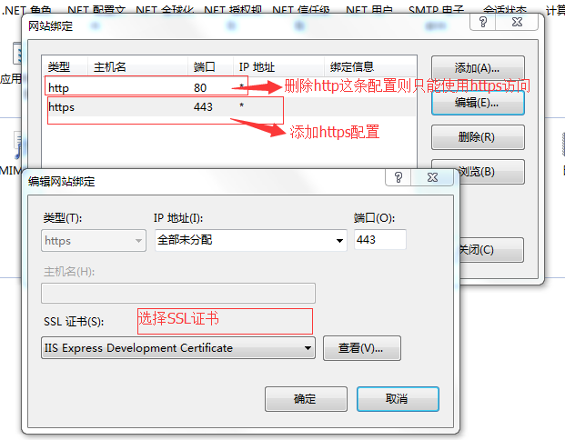

2、针对K3Cloud文件存储支持Https还需要进行以下配置修改

如果应用服务器和文件服务器部署在同一台机器，并且配置了HTTPS，那么需要同时配置Website\Web.config和FileService\Web.config文件；

如果应用服务器和文件服务器部署在不同的机器，文件服务器是内网部署，不用担心网络安全问题，则只需要考虑应用服务器配置HTTPS，那么只修改应用服务器站点目录下的Website\Web.config文件；

注：文件服务器存储目录和FileService目录，有时候除了配置NetWork Service权限，特殊情况下还需要再配置everyone权限。

### 应用服务器文件配置

**应用服务器目录文件：Kingdee\K3Cloud\WebSite\Web.config**

步骤一：

修改前：

<service name="Kingdee.BOS.Web.FileServer.FileServerService" behaviorConfiguration="FileServerBehavior">

<endpoint address="" behaviorConfiguration="webBehavior" binding="webHttpBinding" bindingConfiguration="webBinding" contract="Kingdee.BOS.Web.FileServer.IFileServerService" />

<endpoint address="mex" binding="mexHttpBinding" contract="IMetadataExchange" />

</service>

修改后：

<service name="Kingdee.BOS.Web.FileServer.FileServerService" behaviorConfiguration="FileServerBehavior">

<endpoint address="" behaviorConfiguration="webBehavior" binding="webHttpBinding" bindingConfiguration="webBinding" contract="Kingdee.BOS.Web.FileServer.IFileServerService" />

<endpoint address="mex" binding="mexHttpsBinding" contract="IMetadataExchange" />

</service>

步骤二：

修改前：

<behavior name="FileServerBehavior">

<serviceMetadata httpGetEnabled="true" />

<serviceDebug includeExceptionDetailInFaults="True" />

</behavior>

修改后：

<behavior name="FileServerBehavior">

<serviceMetadata httpsGetEnabled="true" />

<serviceDebug includeExceptionDetailInFaults="True" />

</behavior>

步骤三：

修改前：

<webHttpBinding>

<binding name="ReportServiceRestBinding" closeTimeout="00:05:00" openTimeout="00:05:00" receiveTimeout="00:10:00" sendTimeout="00:05:00" maxReceivedMessageSize="9223372036854775807" transferMode="Streamed" />

<binding name="webBinding" maxReceivedMessageSize="9223372036854775807" transferMode="Streamed" />

</webHttpBinding>

修改后：

<webHttpBinding>

<binding name="ReportServiceRestBinding" closeTimeout="00:05:00" openTimeout="00:05:00" receiveTimeout="00:10:00" sendTimeout="00:05:00" maxReceivedMessageSize="9223372036854775807" transferMode="Streamed" />

<binding name="webBinding" maxReceivedMessageSize="9223372036854775807" transferMode="Streamed" >

<security mode="Transport">

</security>

</binding>

</webHttpBinding>

### 文件服务器文件配置

**文件服务器目录文件：Kingdee\K3Cloud\FileService\Web.config**

步骤一：

修改前：

<behavior name="FileServerBehavior">

<serviceMetadata httpGetEnabled="true" />

<serviceDebug includeExceptionDetailInFaults="true" />

</behavior>

修改后：

<behavior name="FileServerBehavior">

<serviceMetadata httpsGetEnabled="true" />

<serviceDebug includeExceptionDetailInFaults="true" />

</behavior>

步骤二：

修改前：

<webHttpBinding>

<binding name="webBinding" maxReceivedMessageSize="9223372036854775807" transferMode="Streamed" />

</webHttpBinding>

修改后：

<webHttpBinding>

<binding name="webBinding" maxReceivedMessageSize="9223372036854775807" transferMode="Streamed" >

<security mode="Transport">

</security>

</binding>

</webHttpBinding>

步骤三：

修改前：

<service name="Kingdee.BOS.FileServer.Web.FileService" behaviorConfiguration="FileServerBehavior">

<endpoint address="" behaviorConfiguration="webBehavior" binding="webHttpBinding" bindingConfiguration="webBinding" contract="Kingdee.BOS.FileServer.Core.IFileServiceJSON" />

<endpoint address="mex" binding="mexHttpBinding" contract="IMetadataExchange" />

<!--<endpoint address="" binding="customBinding" behaviorConfiguration="webBehavior" bindingConfiguration="JSONMapper" contract="Kingdee.BOS.FileServer.Core.IFileService"></endpoint>-->

</service>

修改后：

<service name="Kingdee.BOS.FileServer.Web.FileService" behaviorConfiguration="FileServerBehavior">

<endpoint address="" behaviorConfiguration="webBehavior" binding="webHttpBinding" bindingConfiguration="webBinding" contract="Kingdee.BOS.FileServer.Core.IFileServiceJSON" />

<endpoint address="mex" binding="mexHttpsBinding" contract="IMetadataExchange" />

<!--<endpoint address="" binding="customBinding" behaviorConfiguration="webBehavior" bindingConfiguration="JSONMapper" contract="Kingdee.BOS.FileServer.Core.IFileService"></endpoint>-->

</service>